Name: Jay Rajesh Umap

Roll No.: 2205010

Enrollment No.: MITU20BTIT0029

Class: LY IT Core

Assignment No. 5: Solidity (Part 2)

Execute the following code in remix ide (<https://remix.ethereum.org/>)

// SPDX-License-Identifier: GPL-3.0

pragma solidity >= 0.6.0 < 0.9.0;

/\*\*

    \* @title Storage

    \* @dev Store & retrieve value in a variable

    \* @custom:dev-run-script contracts/test2.sol

 \*/

contract pay {

    address payable user = payable (0x5B38Da6a701c568545dCfcB03FcB875f56beddC4);

    function payEther() public payable {

    }

    function getBalance() public view returns (uint){

        return address(this).balance;

    }

    function transferTiAccount() public {

        user.transfer(2 ether);

    }

}

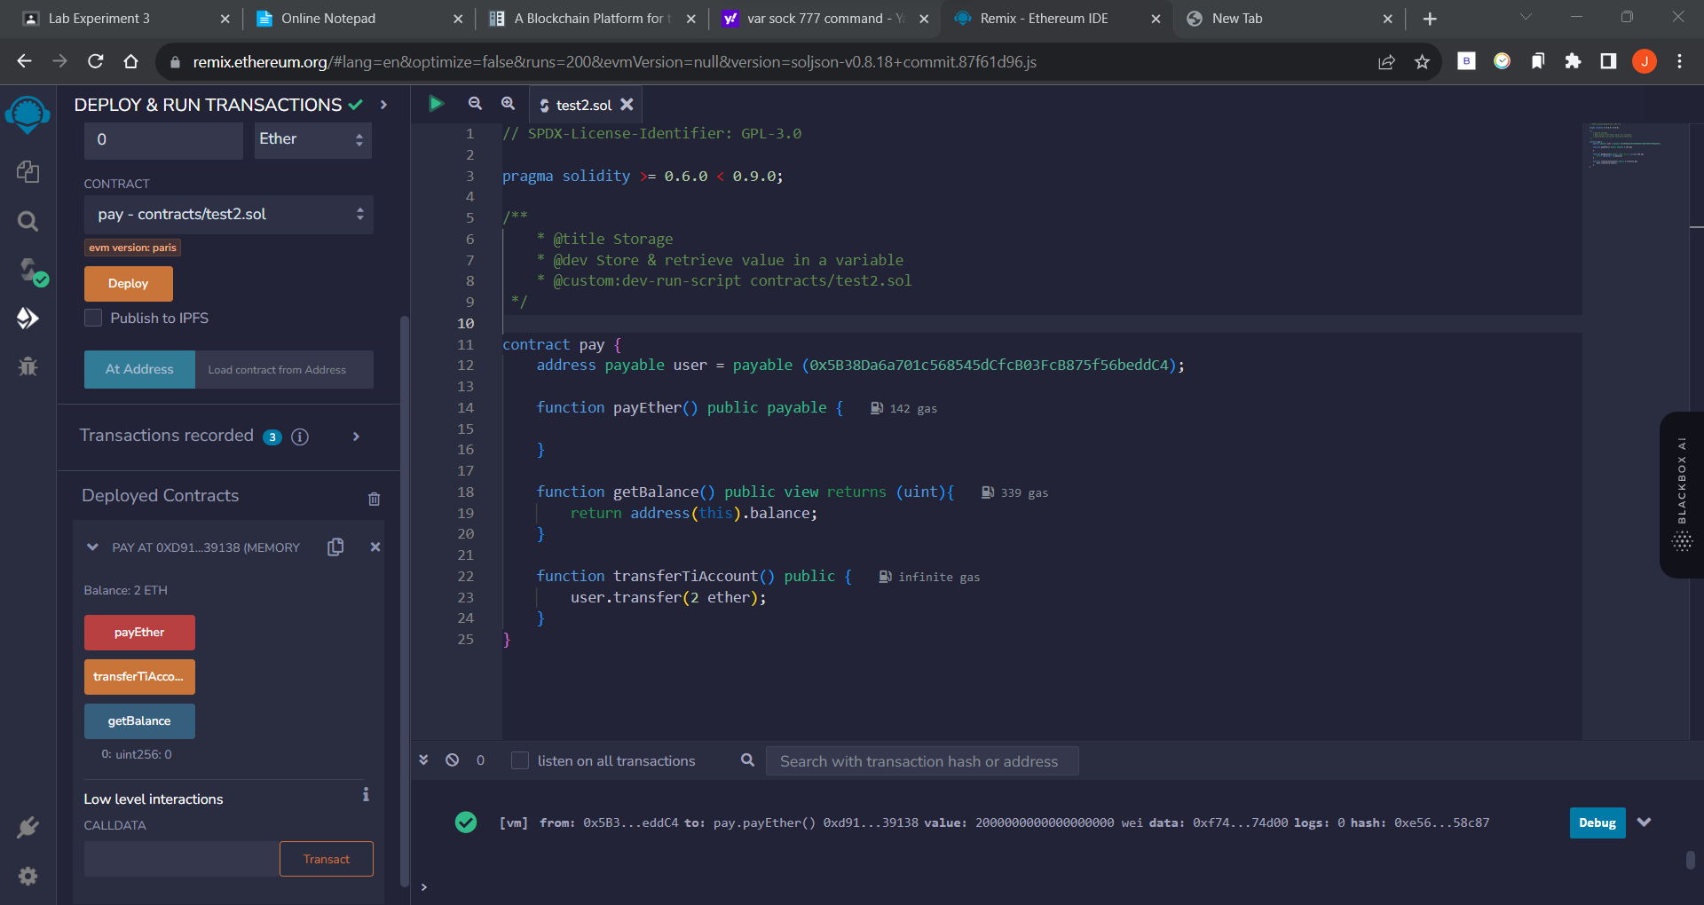Output:

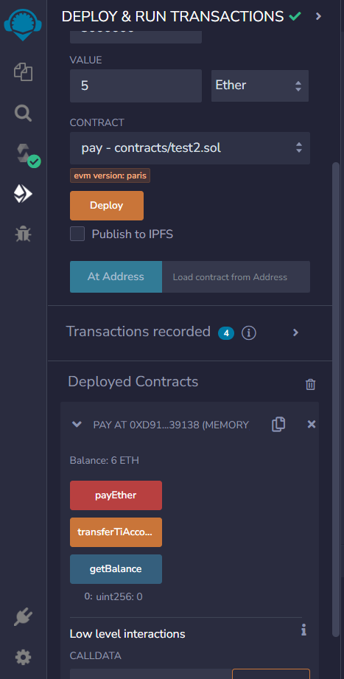

Get Balance using getBalance function (current balance 6 ETH)

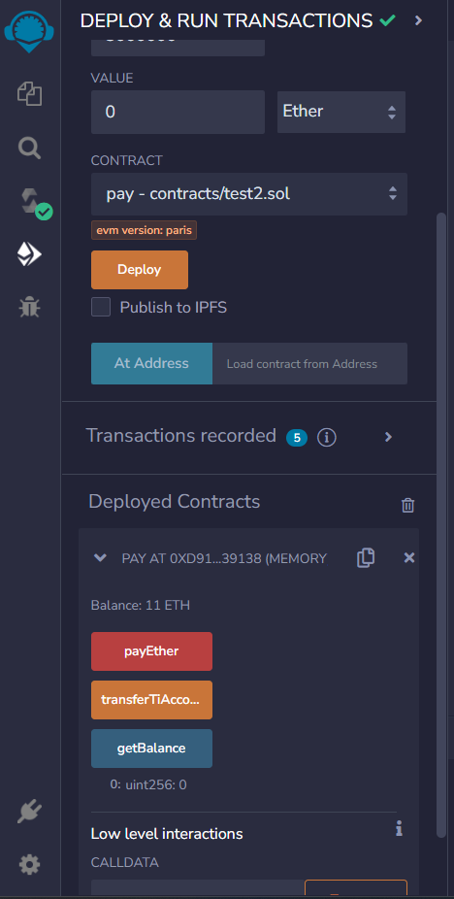

Add Ether to account (adding of 5 ETH) (current balance 11 ETH)

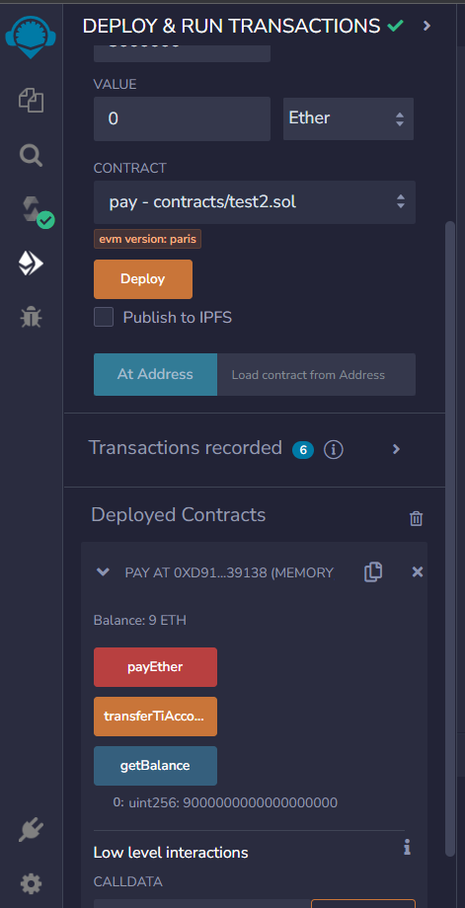

Transfer ether to account (2 ETH Transferred) (current balance 9 ETH)